

[Document title]

[Document subtitle]



[Date]

[Company name]

[Company address]

Contents

List of Figure 1

Code 2

1) 2

2) Test Case Example 2

Output 4

# List of Figure

Figure 1: Example 01 3

Figure 2: Example 02 4

Figure 3: Example 03 5

Figure 4: Example 04 6

# Code

## 1)

function [ x, residue] = constr_linear_opt( A, b,M )

D=svd(A);

n=size(D);

n=n(1);

x1=A\b;

temp=sqrt(sum(x1.^2));

while (1)

if(temp<=M)

x=x1;

residue=A*x(1:n) - b;

residue=sqrt(sum(residue.^2));

break

else

y=(b/D);

x=x1;

while(1)

val=y(n).^2;

x=x-val;

temp=sqrt(sum(x.^2));

if (temp<=M)

break

else

if (n>1)

n=n-1;

end

end

break

end

residue=A*x -b;

residue=sqrt(sum(residue.^2));

break

end

end

end

## 2) Test Case Example

% Algebra and Geometry, GETIAE, UPC-UPF

% Constrained linear optimization assignment: verification script

% Year 2019/20

%

% Prepared by Kenneth Ros and Jaume Amoros

% Example 1: system with unique exact solution, which complies the

% constrain

clc

clear all

A1=[1,3,2;2,0,3;1,-1,1];

b1=[5;-1;3];

M1=30;

'Correct solution'

x1c=A1\b1

residue1c=0

% 'Tested function answers'

[x1,residue1]=constr_linear_opt(A1,b1,M1)

pause

% Example 2: system with unique exact solution, which does not comply the

% constrain; only the last component has to be emptied

A2=A1;

b2=b1;

M2=28;

'Correct solution'

x2c =[22.8614,4.4049,-15.5548]'

residue2c=0.1191

'Tested function answers'

[x2,residue2]=constr_linear_opt(A2,b2,M2);

pause

% Example 3: again system with unique exact solution, which does not comply the

% constrain, and more than one component has to be emptied

A3=diag([4,3,2,1]);

b3=[8;6;4;-2];

M3=3.2;

'Correct solution'

x3c =[2,2,1.4967,0]'

residue3c=2.2391

'Tested function answers'

[x3,residue3]=constr_linear_opt(A3,b3,M3);

pause

% Exemple 4: incompatible system, where the solution just minimizes the

% residue

A4=[4,3,2,1;

1,5,2,2;

3,6,3,0;

1,0,1,2;

3,8,8,4];

b4=[8;6;4;-2;0];

M4=0.1*norm(A4\b4) %delta4 = 0.3321, the constrain is tough here

'Correct solution'

x4c =[0.1097,0.2377,0.1842,0.0885]'

residue4c=9.1412

'Tested function answers'

[x4,residue4]=constr_linear_opt(A4,b4,M4);

% Missing examples that the user should add:

% Two compatible, undetermined (multiple solutions) linear systems, one

% with an exact solution complying the constraint, another where no exact

% solution satisfies it.

# Output

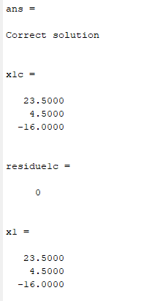

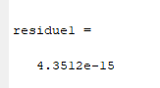

Figure : Example 01

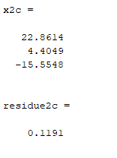

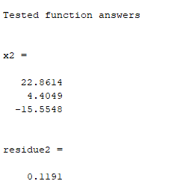

Figure : Example 02

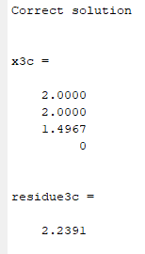

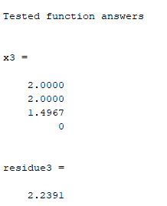

Figure : Example 03

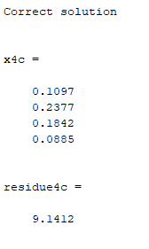

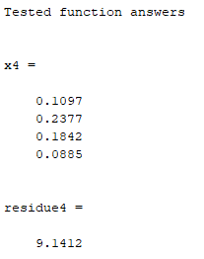

Figure : Example 04